***Testing and Inspection Report***

**

***Unit Test & Inspection Report***

***Prepared by:***

***Chirag Soni***

***Deepika Tripathi***

***Harsh Jain***

***Srinath Karimpuzha***

**For use in CS 440**

**at the**

**University of Illinois Chicago**

**November 2018**

**Table of Contents**

I Project Description 3

1 Project Overview 3

2 Project Domain 3

3 Relationship to Other Documents 3

4 Naming Conventions and Definitions 3

4a Definitions of Key Terms 3

4b UML and Other Notation Used in This Document 4

4c Data Dictionary for Any Included Models 4

II Testing 4

5 Items to be Tested 4

6 Test Specifications 5

7 Test Results 18

III Inspection 23

8 Items to be Inspected 23

9 Inspection Procedures 24

10 Inspection Results 25

IV Recommendations and Conclusions 32

V Project Issues 32

11 Waiting Room 32

12 Project Retrospective 33

VI Glossary 33

VII References / Bibliography 34

VIII Index 34

# Project Description

## Project Overview

This product is designed for developers and project managers for project management. Furthermore, this product is tailored for agile programming processes; users of this product will be able to setup sprints for incremental development, as well as declare, modify, and remove features from the product when desired.

## Project Domain

The project mainly focusses on project management efficiently as development teams include various levels of dependencies and communications between teams.

## Relationship to Other Documents

Software Engineering project report of Nouveau Scrum [1] is referred for this project. Sections referred are:

* Project Description section.
* Project Requirement section.
* Project Design section.

## Naming Conventions and Definitions

### Definitions of Key Terms

Sandbox: Initial stage where any person related or not related to the project can provide ideas. User stories are created here.

Features: Functional Requirements are categorized into features.

Project: A project is a collection of stories and sprints. The system allows multiple people to join a project and create/view stories and sprints within a project.

Timeline: Timeline will contain all release and sprint level info along with the user stories and schedule of the project.

Task: A specific task that needs to implement a feature described by a story.

Sprint: A time period that has a start date and an end date. The system allows users to assign stories to a sprint. The goal is to create a deadline for stories to be implemented.

Story: An explanation of a feature that needs to be implemented. The system allows developers to create stories and places them in the project Sandbox. A manager can accept to story, moving it to the Product Backlog, or reject the story, removing it from the Sandbox.

Product Backlog: All User stories accepted by the project manager are stored in product backlog.

### UML and Other Notation Used in This Document

This document generally follows the Version 2.0 OMG UML standard, as described by Fowler in [4].

### Data Dictionary for Any Included Models

Release plan = Project identifier + Release identifier.

Sprint plan= Release identifier + Project identifier + Sprint identifier.

User Story = Release identifier + Project identifier + Sprint identifier + Story identifier.

Task = Release identifier + Project identifier + Sprint identifier + Story identifier + Task identifier.

# Testing

## Items to be Tested

ID1- Account creation.

ID2- Role Management

ID3- Create Project.

ID4- Update Project.

ID5- Create User Story.

ID6- Update User Story.

ID7- Create Release

ID8- Update Release

ID9- Create Sprint

ID10- Update Sprint.

ID11- Create Feature

ID12- Update Feature.

ID13- Sandbox management.

ID14- Product backlog management.

ID15- Timeline management

ID16- Create Task

ID17- Update Task

## Test Specifications

**ID1- Account Creation**

**Description:** To test whether a new user is able to register into the tool.

**Items covered by this test:** Registration, user authentication and login.

**Environmental needs:** JVM and web browser.

**Inter case Dependencies:** NA

**Test Procedures:**

* + - * 1. Click on Signup button
        2. Enter First name, last name, username, email id
        3. Select a role
        4. Enter password and confirm password
        5. Click submit

**Input Specification:**

* + - * 1. First name: Jonathan
        2. Last name: Pratt
        3. Username: jonpratt19
        4. Email: [jpatt@gmail.com](mailto:jpatt@gmail.com)
        5. Role: Developer.
        6. Password: 123456
        7. Confirm Password: 123456

**Output Specifications:** An user account is created and an entry is created in the user table with the above mentioned details.

**Pass/Fail Criteria:** The test is considered pass when the created user is able to login using his username and password.

**ID2- Role Management**

**Description:** To test whether a the logged in user is either developer or project manager and appropriate access privileges are provided.

**Items covered by this test:** Access privileges and login.

**Environmental needs:** JVM and web browser.

**Inter case Dependencies:** ID11, ID3

**Test Procedures:**

* + - * 1. In Login page, enter username, and password.
        2. Click on login button.
        3. Check if dashboard has create project button for project manager.
        4. Check if create release button is present in timeline for a project manager.

**Input Specification:**

* + - * 1. Username: jonpratt19
        2. Password: 123456

**Output Specifications:** An user can create project and create feature when the user is a project manager only, while a developer cannot.

**Pass/Fail Criteria:** The test is considered pass when the project manager can create a feature and create project while a developer cannot.

**ID3- Create Project**

**Description:** To test whether the logged in user is project manager and create a project.

**Items covered by this test:** Create a new project and dashboard

**Environmental needs:** JVM and web browser.

**Inter case Dependencies:** ID1, ID2

**Test Procedures:**

* + - * 1. In dashboard kindly click on create project button.
        2. Enter the project details and click submit
        3. Check in project table whether a new entry has been created.

**Input Specification:**

* + - * 1. Project name: Project 1
        2. Project Description: Project 1 is a project on Machine Learning.
        3. Created By: 1
        4. Owner: jmatt12
        5. Members: srinath1992, hjain20
        6. Project type: Public
        7. Start date: 07/22/2018
        8. End date: 07/22/2019
        9. Sprint duration: 12

**Output Specifications:** A user can create project, while a developer cannot.

**Pass/Fail Criteria:** The test is considered pass when the project manager can create project by filling the above details in the form.

**ID4- Update Project**

**Description:** To test whether the user can update the existing project details.

**Items covered by this test:** Updating the details of an existing project.

**Environmental needs:** JVM and web browser.

**Inter case Dependencies:** ID3

**Test Procedures:**

* + - * 1. In dashboard, select a project.
        2. Edit the project details and click submit
        3. Check in project table whether a edited information is visible

**Input Specification:**

Edit any one of the project details

* + - * 1. Project name: Project 1
        2. Project Description: Project 1 is a project on Machine Learning and AI.
        3. Created By: 1
        4. Owner: jmatt12
        5. Members: srinath1992, hjain20, csoni3
        6. Project type: Public
        7. Start date: 07/22/2018
        8. End date: 07/22/2019
        9. Sprint duration: 12

**Output Specifications:** A user can edit details of an existing project.

**Pass/Fail Criteria:** The test is considered pass when user can edit details of the existing project.

**ID5- Create User Story**

**Description:** To test whether the logged in user can create a user story.

**Items covered by this test:** Sandbox and create user story

**Environmental needs:** JVM and web browser.

**Inter case Dependencies:** ID13

**Test Procedures:**

* + - * 1. In sandbox kindly click on create story button.
        2. Enter the story details and click submit
        3. Check in user_story table whether a new entry has been created.

**Input Specification:**

* + - * 1. Story name: Story 1
        2. Story Description: Story 1 description
        3. Created By: 1
        4. Created On: 07/22/2018
        5. Feature: select from dropdown
        6. Estimation: srinath1992, hjain20
        7. Project type: Public
        8. Start date: 07/22/2018
        9. End date: 07/22/2019
        10. Sprint duration: 12

**Output Specifications:** An user can create project, while a developer cannot.

**Pass/Fail Criteria:** The test is considered pass when the project manager can create project by filling the above details in the form.

**ID6- Update User Story**

**Description:** To test whether the logged in user can update a user story.

**Items covered by this test:** Sandbox and update user story

**Environmental needs:** JVM and web browser.

**Inter case Dependencies:** ID13

**Test Procedures:**

* + - * 1. In sandbox kindly click on create story button.
        2. Enter the story details and click submit
        3. Check in user_story table whether a new entry has been created.

**Input Specification:**

* + - * 1. Story name: Story 1
        2. Story Description: Story 1 description
        3. Created By: 1
        4. Created On: 07/22/2018
        5. Feature: select from dropdown
        6. Estimation: srinath1992, hjain20
        7. Project type: Public
        8. Start date: 07/22/2018
        9. End date: 07/22/2019
        10. Sprint duration: 12

**Output Specifications:** An user can create project, while a developer cannot.

**Pass/Fail Criteria:** The test is considered pass when the project manager can create project by filling the above details in the form.

**ID7- Create Release**

**Description:** To test whether the details of an already created release is retrieved properly.

**Items covered by this test:** Update release

**Environmental needs:** JVM and web browser.

**Intercase Dependencies:** ID4

**Test Procedures:**

1. Select a project
2. Release Number
3. Start Date
4. End Date
5. Click Save

**Input Specification:**

1. Project name: Proj1
2. Release Number: 1
3. Start Date: 05/22/2018
4. End Date: 06/22/2018

**Output Specifications:** A new release is created with a unique id and appropriate start and end dates.

**Pass/Fail Criteria:** The test is considered pass when a new release is created, and the entry details are populated in the database table.

**ID8- Update Release**

**Description:** To test whether a new release is been created with appropriate start and end dates.

**Items covered by this test:** Create new release

**Environmental needs:** JVM and web browser.

**Intercase Dependencies:** ID7

**Test Procedures:**

Select a project

Click on Timeline

Select Release

Update any field e.g., End Date

Click Save

**Input Specification:**

Project name: Proj1

Release Number: R1

New end date: 07/22/18

Updated end date as 07/22/18

**Output Specifications:** A release is updated with all the changes required.

**Pass/Fail Criteria:** The test is considered pass when an already existing release is updated, and the values get reflected in the database table as well.

**ID9- Create Sprint**

**Description:** To test whether a new sprint is been created with a unique sprint id along with appropriate start and end dates.

**Items covered by this test:** Create new sprint

**Environmental needs:** JVM and web browser.

**Inter case Dependencies:** ID7

**Test Procedures:**

Select a release

Create Sprint

Enter new value of fields e.g., Start Date

Click Save

**Input Specification:**

Release Number: R1

New Start Date: 07/26/18

**Output Specifications:** A new sprint is created under the release selected as above.

**Pass/Fail Criteria:** The test is considered pass when new sprint is created with a new id.

**ID10- Update Sprint**

**Description:** To test whether an existing sprint details can be updated successfully.

**Items covered by this test:** update new sprint

**Environmental needs:** JVM and web browser.

**Intercase Dependencies:** ID9

**Test Procedures:**

Select a Release

Select a Sprint

Update value of Start Date

Click Save

**Input Specification:**

Release Number: R1

Sprint Number: S1

New Start Date: 07/30/18

Updated Start Date

**Output Specifications:** Selected sprint is updated with the relevant fields to be changed.

**Pass/Fail Criteria:** The test is considered pass when an existing sprint is updated with all updated values getting reflected in the database table.

**ID11- Create Feature**

**Description:** To test whether a new feature is created that defines the requirement of a particular project.

**Items covered by this test:** Create a new feature.

**Environmental needs:** JVM and web browser.

**Intercase Dependencies:** ID4

**Test Procedures:**

Select a project

Input feature name

Input Created By ID

Input Efforts

Input Priority

Click Save

**Input Specification:**

Project Name: Proj1

Feature Name: Account Management

Created By ID: 2

Efforts: 5

Priority: 10

**Output Specifications:** A new feature is been created with all its details fed by the user (manager or developer) with the data stored in the database table.

**Pass/Fail Criteria:** The test is considered pass when a new feature is created with all its fields saved in the database successfully.

**ID12- Update Feature**

**Description:** To test whether the manager is able to update the feature created.

**Items covered by this test:** Feature details to be updated.

**Environmental needs:** JVM and web browser.

**Inter case Dependencies:** Test ID11 should pass.

**Test Procedures:**

Select a previously created project from dashboard.

Select Features from left side menu.

Select a previously created feature.

Edit the values in the update form.

Click on the Save button.

**Input Specification:**

Efforts Required: 1.0

**Output Specifications:** Theefforts required for selected feature gets updated to 1.0.

**Pass/Fail Criteria:** The test is considered pass when the view feature shows efforts required as “1.0”.

**ID13- Sandbox Management**

**Description:** To test whether the project has a Sandbox stage with ability to view accepted user stories.

**Items covered by this test:** Sandbox stage of the project.

**Environmental needs:** JVM and web browser.

**Inter case Dependencies:** Test ID 3 should pass.

**Test Procedures:**

1.Select a previously created project from dashboard.

2.Select Sandbox from left side menu.

**Input Specification:** Project: Project1

**Output Specifications:** All the lists of initial stories should be displayed on the sandbox.

**Pass/Fail Criteria:** The test is considered pass when the sandbox of the selected project displays list of initial stories with an option to create more user stories.

**ID14- Product Backlog Management**

**Description:** To test whether the project has a product backlog stage with ability to view accepted user stories.

**Items covered by this test:** Product Backlog stage of the project.

**Environmental needs:** JVM and web browser.

**Inter case Dependencies:** Test ID 3 should pass.

**Test Procedures:**

1.Select a previously created project from dashboard.

2.Select Product Backlog from left side menu.

**Input Specification:** Project: Project1

**Output Specifications:** All the lists of accepted stories should be displayed on the product backlog which can be moved to sprints.

**Pass/Fail Criteria:** The test is considered pass when the product backlog of the selected project displays list accepted stories with an option to move user stories.

**ID15- Timeline Management**

**Description:** To test whether the project has a timeline module with list of releases for the project.

**Items covered by this test:** Timeline module of the project.

**Environmental needs:** JVM and web browser.

**Inter case Dependencies:** Test ID 3 should pass.

**Test Procedures:**

1.Select a previously created project from dashboard.

2.Select Timeline from left side menu.

**Input Specification:** Project: Project1

**Output Specifications:** The list of releases and their sprint plans are displayed as part of project timeline.

**Pass/Fail Criteria:** The test is considered pass when the left side menu changes to timeline view with list of releases and their sprint plans on the screen.

**ID16- Create Task**

**Description:** To test that the user is able to create a new task in a user story.

**Items covered by this test:** Tasks of a user story.

**Environmental needs:** JVM and web browser.

**Inter case Dependencies:** Test ID 5 should pass.

**Test Procedures:**

1.Select a previously created project from dashboard.

2.Select Timeline from left side menu.

3. Select a sprint from the list.

4. Click on “View Tasks” button.

5. Click on “Create Task” button.

6. Fill all the task details (Task name, description, story number, estimation, assigned To, Priority, status).

7. Click on “Save” button.

**Input Specification:**

* Task name: Task1
* Description: First Task
* Story Number: Story1
* Estimation: 4
* Assigned To: User1
* Priority: 2
* Status: To Do

**Output Specifications:** The task gets created with all abovementioned details.

**Pass/Fail Criteria:** The test is considered pass when list of tasks inside the story1 shows Task1.

**ID17- Update Task**

**Description:** To test that the user is able to update a created task in a user story.

**Items covered by this test:** Tasks of a user story.

**Environmental needs:** JVM and web browser.

**Inter case Dependencies:** Test ID 16 should pass.

**Test Procedures:**

1.Select a previously created project from dashboard.

2.Select Timeline from left side menu.

3. Select a sprint from the list.

4. Click on “View Tasks” button.

5. Select a task

6. Update the task status.

7. Click on “Save” button.

**Input Specification:**

* Status: Done

**Output Specifications:** The task status gets updated with all abovementioned details.

**Pass/Fail Criteria:** The test is considered pass when status of task1 inside the story1 changes to “Done”.

## Test Results

**ID1 – Account Creation**

**Date(s) of Execution:** 11/23/2018

**Staff conducting tests:** Srinath Karimpuzha

**Expected Results:** The test is considered pass when the created user is able to login using his username and password.

**Actual Results:** The test passes since the created user is able to login using his username and password.

**Test Status:** Pass

**ID2 – Role Management**

**Date(s) of Execution:** 11/23/2018

**Staff conducting tests:** Srinath Karimpuzha

**Expected Results:** The test is considered pass when the project manager can create a feature and create project while a developer cannot.

**Actual Results:** The test passes since the project manager can create a feature and create project while a developer cannot.

**Test Status:** Pass

**ID3 – Create Project**

**Date(s) of Execution:** 11/23/2018

**Staff conducting tests:** Srinath Karimpuzha

**Expected Results:** The test is considered pass when the project manager can create project by filling the above details in the form.

**Actual Results:** The test is passes since the project manager can create project by filling the above details in the form.

**Test Status:** Pass

**ID4 – Update Project**

**Date(s) of Execution:** 11/24/2018

**Staff conducting tests:** Srinath Karimpuzha

**Expected Results:** The test is considered pass when user can edit details of the existing project.

**Actual Results:** The test is passes since user can edit details of the existing project.

**Test Status:** Pass

**ID5 – Create User Story**

**Date(s) of Execution:** 11/24/2018

**Staff conducting tests:** Deepika Tripathi

**Expected Results:** The test is considered pass when the project manager can create project by filling the above details in the form.

**Actual Results:** The test passes since the project manager can create project by filling the above details in the form.

**Test Status:** Pass

**ID6 – Update User Story**

**Date(s) of Execution:** 11/24/2018

**Staff conducting tests:** Deepika Tripathi

**Expected Results:** The test is considered pass when the project manager can create project by filling the above details in the form.

**Actual Results:** The test is passes since the project manager can create project by filling the above details in the form.

**Test Status:** Pass

**ID7 – Create Release**

**Date(s) of Execution:** 11/25/2018

**Staff conducting tests:** Deepika Tripathi

**Expected Results:** The test is considered pass when a new release is created, and the entry details are populated in the database table.

**Actual Results:** The test is passes since a new release is created, and the entry details are populated in the database table.

**Test Status:** Pass

**ID8 – Update Release**

**Date(s) of Execution:** 11/25/2018

**Staff conducting tests:** Deepika Tripathi

**Expected Results:** The test is considered pass when an already existing release is updated, and the values get reflected in the database table as well.

**Actual Results:** The test is passes since an already existing release is updated, and the values get reflected in the database table as well.

**Test Status:** Pass

**ID9 – Create Sprint**

**Date(s) of Execution:** 11/25/2018

**Staff conducting tests:** Chirag Soni

**Expected Results:** The test is considered pass when new sprint is created with a new id.

**Actual Results:** The test passes since new sprint is created with a new id.

**Test Status:** Pass

**ID10 – Update Sprint**

**Date(s) of Execution:** 11/26/2018

**Staff conducting tests:** Chirag Soni

**Expected Results:** The test is considered pass when an existing sprint is updated with all updated values getting reflected in the database table.

**Actual Results:** The test is passes since an existing sprint is updated with all updated values getting reflected in the database table.

**Test Status:** Pass

**ID11 – Create Feature**

**Date(s) of Execution:** 11/26/2018

**Staff conducting tests:** Chirag Soni

**Expected Results:** The test is considered pass when a new feature is created with all its fields saved in the database successfully.

**Actual Results** The test is passes since a new feature is created with all its fields saved in the database successfully.

**Test Status:** Pass

**ID12 – Update Feature**

**Date(s) of Execution:** 11/26/2018

**Staff conducting tests:** Chirag Soni

**Expected Results:** The test is considered pass when the view feature shows efforts required as “1.0”.

**Actual Results:** The test passes since the view feature shows efforts required as “1.0”.

**Test Status:** Pass

**ID13 – Sandbox Management**

**Date(s) of Execution:** 11/27/2018

**Staff conducting tests:** Harsh Jain

**Expected Results:** The test is considered pass when the sandbox of the selected project displays list of initial stories with an option to create more user stories.

**Actual Results:** The test is passes since the sandbox of the selected project displays list of initial stories with an option to create more user stories.

**Test Status:** Pass

**ID14 – Product backlog Management**

**Date(s) of Execution:** 11/27/2018

**Staff conducting tests:** Harsh Jain

**Expected Results:** The test is considered pass when the product backlog of the selected project displays list accepted stories with an option to move user stories.

**Actual Results:** The test passes since the product backlog of the selected project displays list accepted stories with an option to move user stories.

**Test Status:** Pass

**ID15 – Timeline Management**

**Date(s) of Execution:** 11/27/2018

**Staff conducting tests:** Harsh Jain

**Expected Results:** The test is considered pass when the left side menu changes to timeline view with list of releases and their sprint plans on the screen.

**Actual Results:** The test passes since the left side menu changes to timeline view with list of releases and their sprint plans on the screen.

**Test Status:** Pass

**ID16 – Create Task**

**Date(s) of Execution:** 11/28/2018

**Staff conducting tests:** Harsh Jain

**Expected Results:** The test is considered pass when list of tasks inside the story1 shows Task1.

**Actual Results:** The test is passes since list of tasks inside the story1 shows Task1.

**Test Status:** Pass

**ID17 – Update Task**

**Date(s) of Execution:** 11/28/2018

**Staff conducting tests:** Harsh Jain

**Expected Results:** The test is considered pass when status of task1 inside the story1 changes to “Done”.

**Actual Results:** The test is passes since status of task1 inside the story1 changes to “Done”.

**Test Status:** Pass

# Inspection

## Items to be Inspected

* + - 1. JSP pages
         1. Registration.jsp
         2. Login.jsp
         3. CreateFeatures.jsp
         4. CreateProject.jsp
         5. CreateRelease.jsp
         6. CreateSprint.jsp
         7. CreateStory.jsp
         8. CreateTask.jsp
         9. Dashboard.jsp
         10. ProductBacklog.jsp
         11. Sandbox.jsp
         12. Timeline.jsp
         13. ViewEditFeature.jsp
         14. ViewEditRelease.jsp
         15. ViewEditSprint.jsp
         16. ViewEditStory.jsp
         17. ViewEditTask.jsp
         18. ViewSprintPlan.jsp
         19. ViewStoryPlan.jsp
         20. ViewUpdateProject.jsp
      2. Java Files
         1. Admin.java
         2. Controller.java
         3. ConnectionProvider.java
         4. Feature.java
         5. Task.java
         6. UserStory.java
         7. Sprint.java
         8. Release.java
         9. Project.java
      3. SQL Scripts
         1. create_feature.sql
         2. create_product_backlog.sql
         3. create_project.sql
         4. create_release.sql
         5. create_sandbox.sql
         6. create_sprint.sql
         7. create_task.sql
         8. create_user_stories.sql
         9. create_user.sql

## Inspection Procedures

* + - 1. We use Sonar Lint plugin to inspect all Java files. The set of rules inspected by Sonar can be found on <https://rules.sonarsource.com/java>
      2. The JSP files were inspected manually. The inspection was of a developer’s code was divided among the other three team mates.
      3. The JS files belong to Bootstrap JS template and were never altered. The template can be found at <https://startbootstrap.com/>
      4. The SQL files were simple scripts written to create initial schema, hence they were not inspected.

## Inspection Results

**Java Files (SonarLint results):**

* **Admin.java**

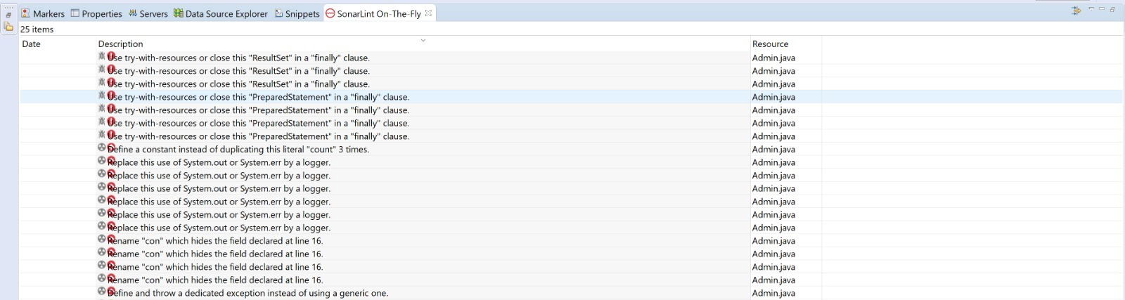

* **Controller.java part1**

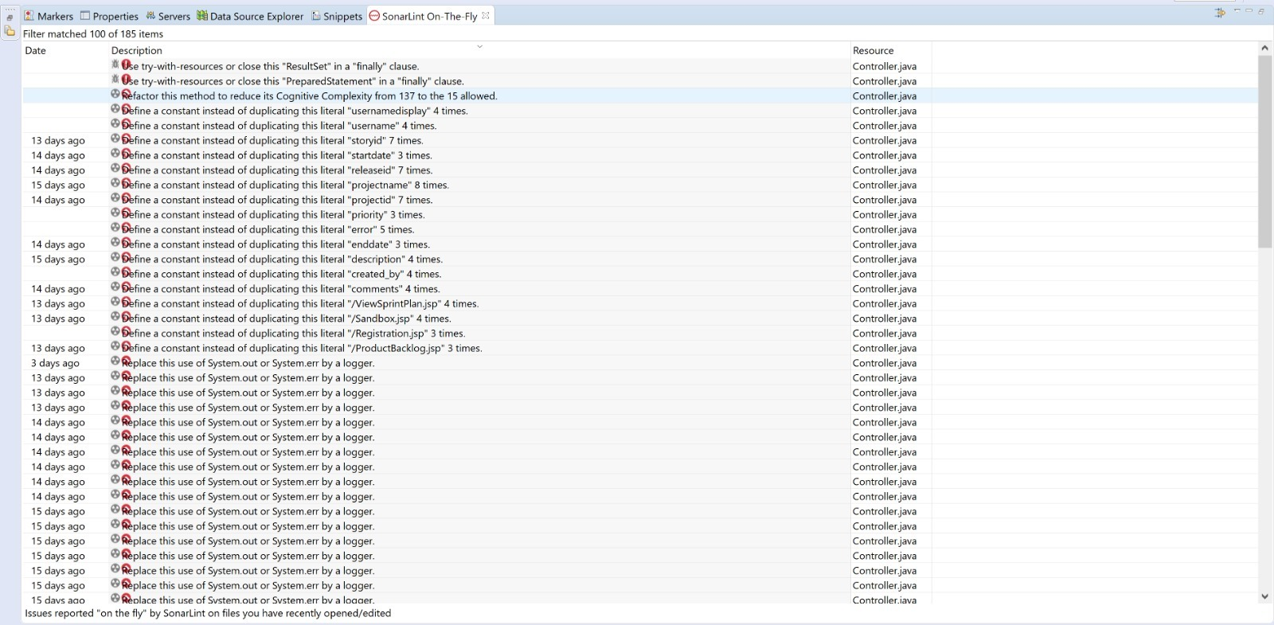

* **Controller.java part2**

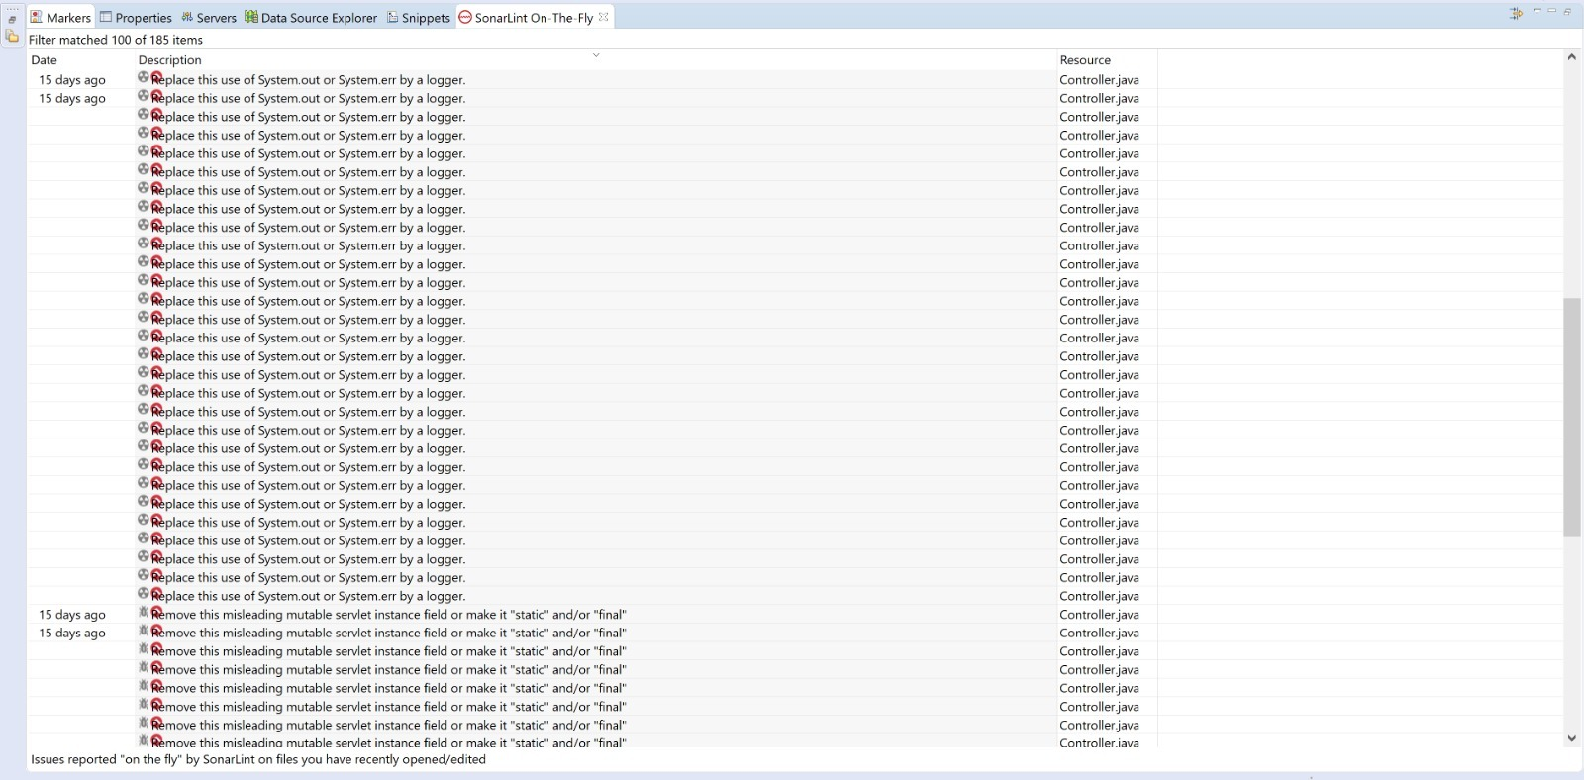

* **Controller.java part3**

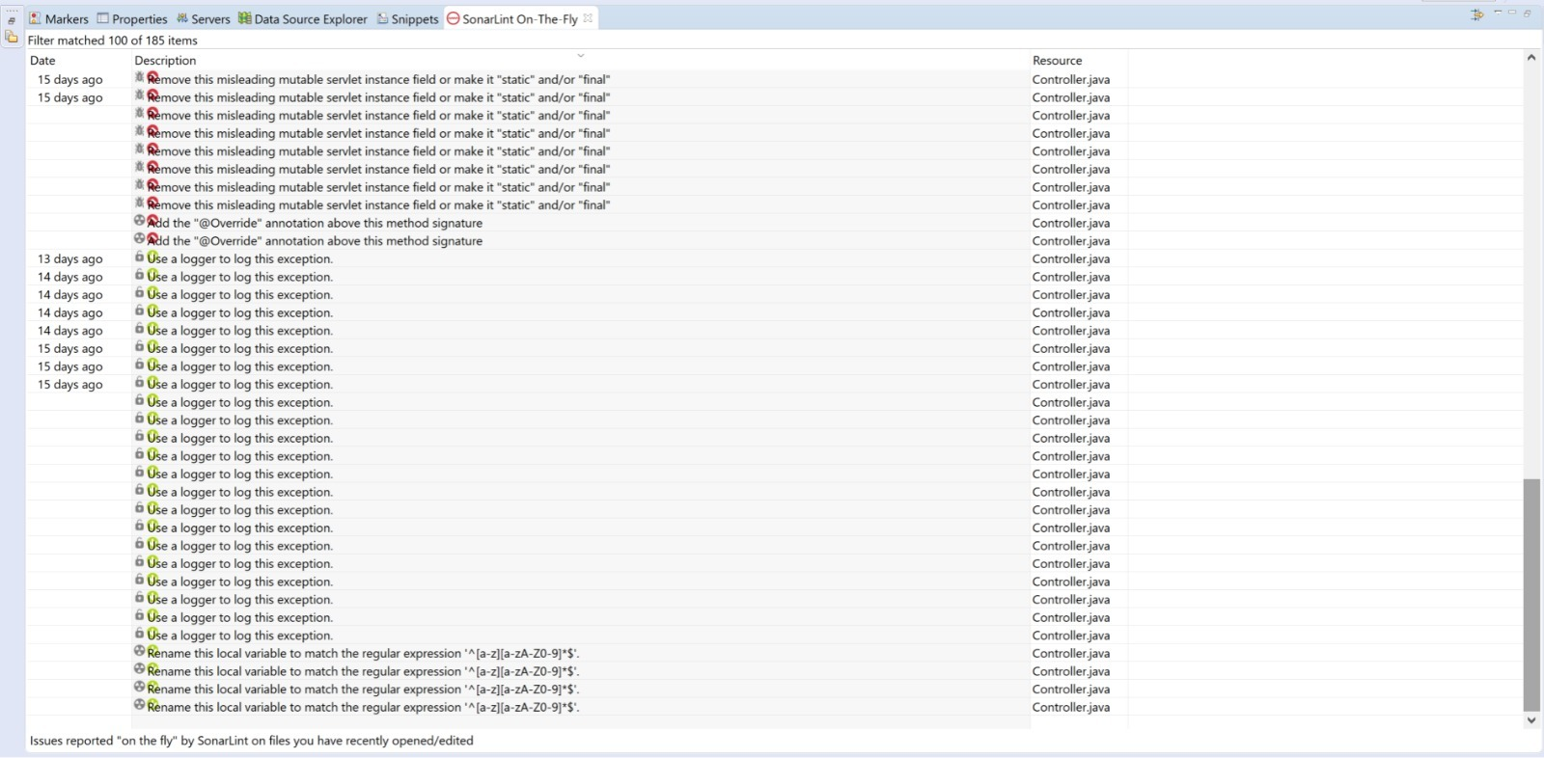

* **Connection Provider.java**

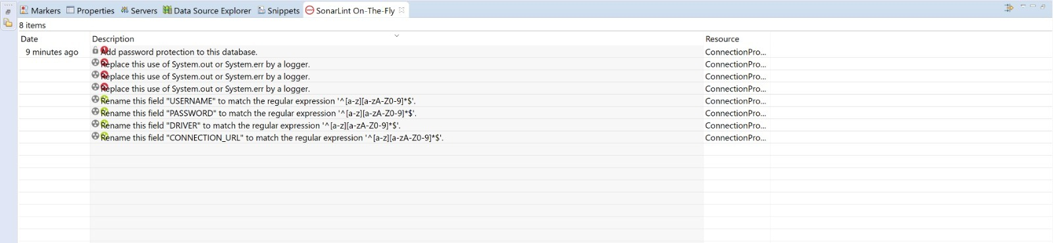

* **Feature.java**

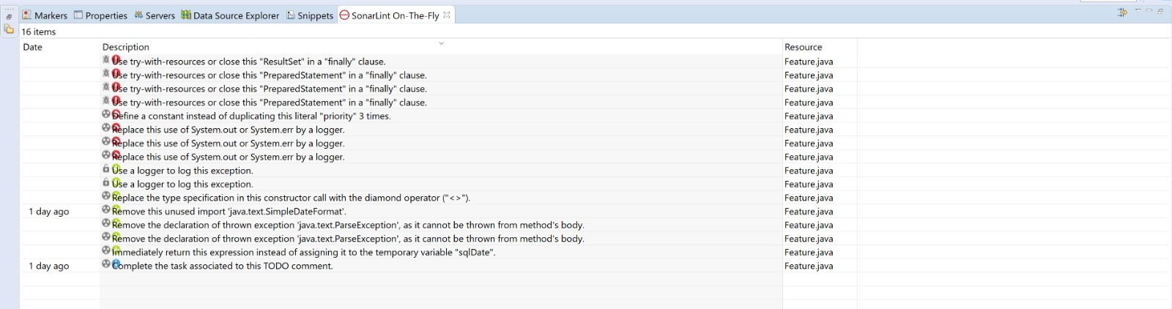

* **Project.java**

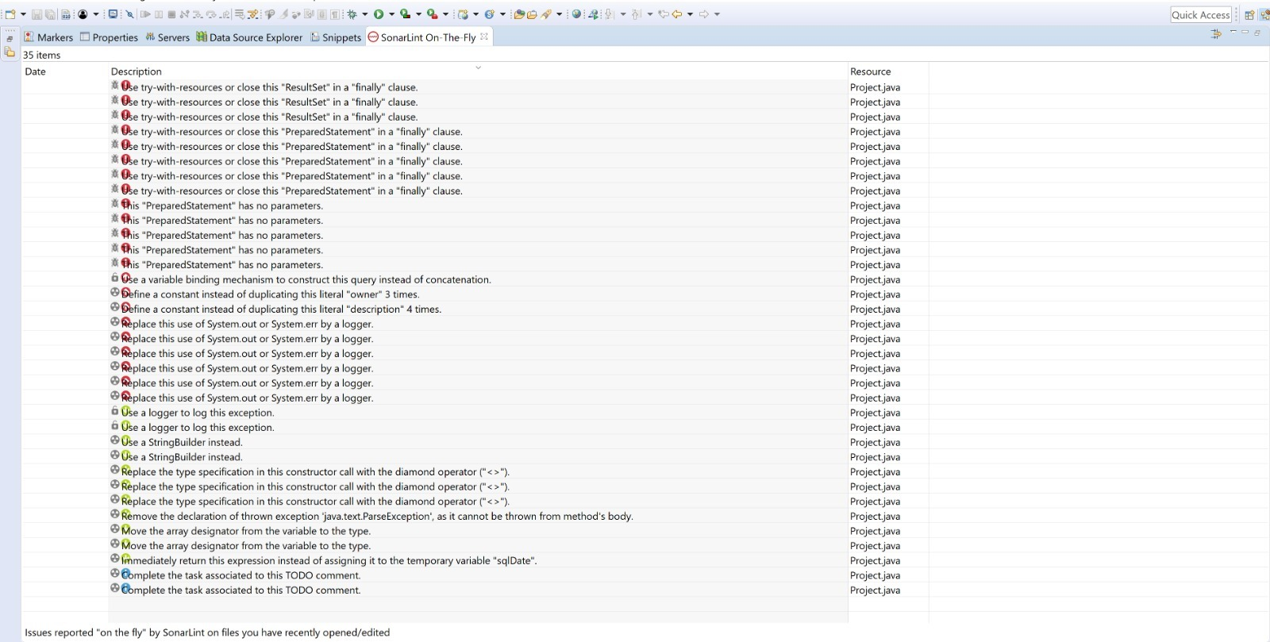

* **Release.java**

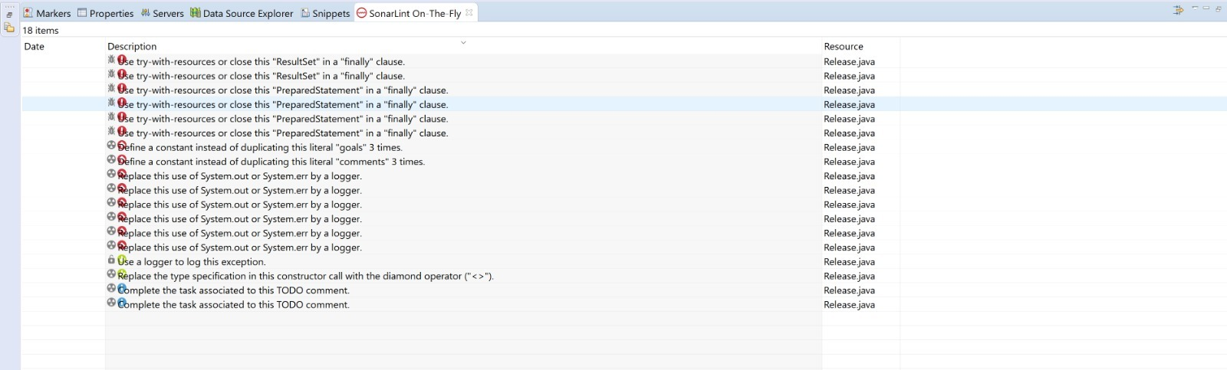

* **Sprint.java**

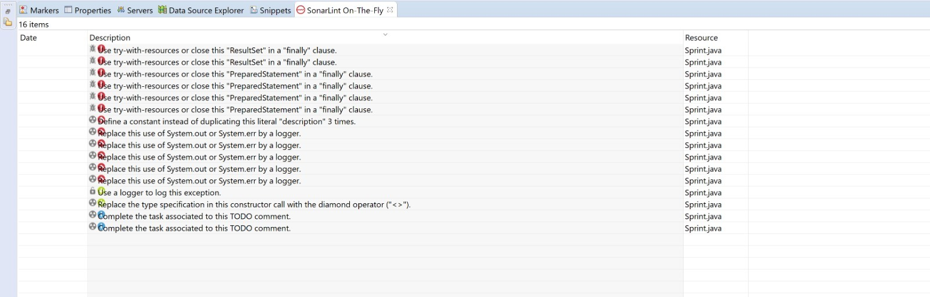

* **Task.java**

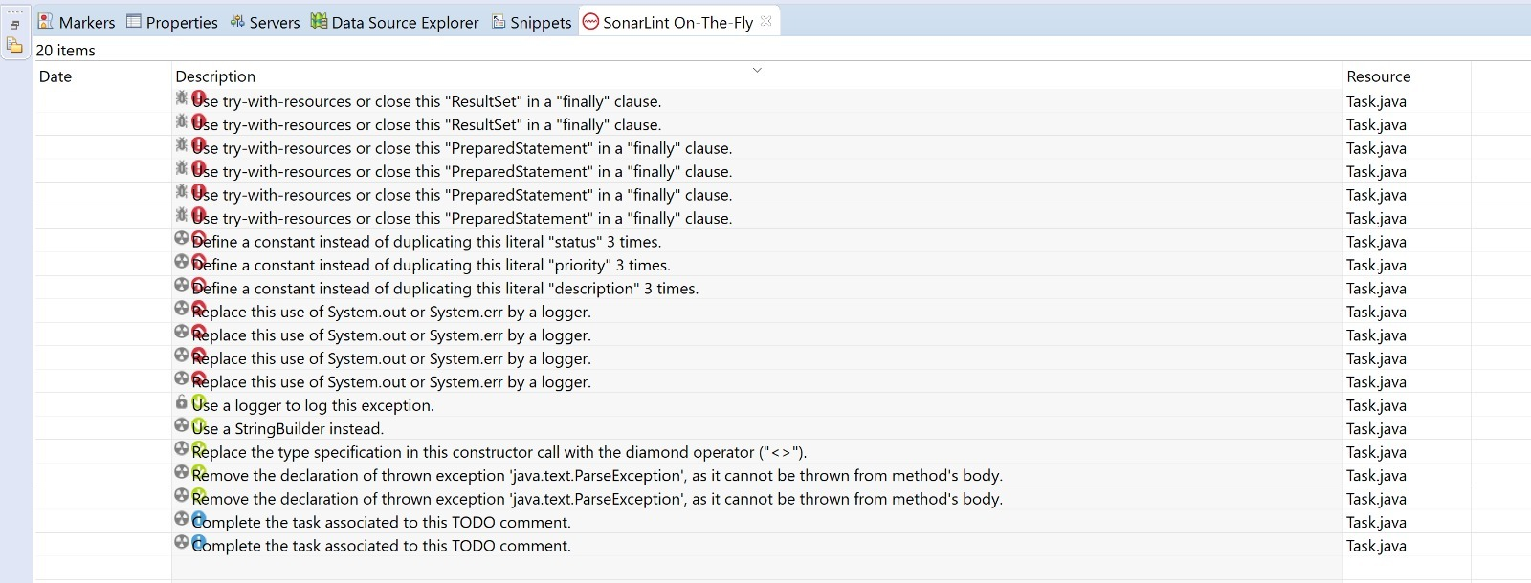

* **UserStory.java**

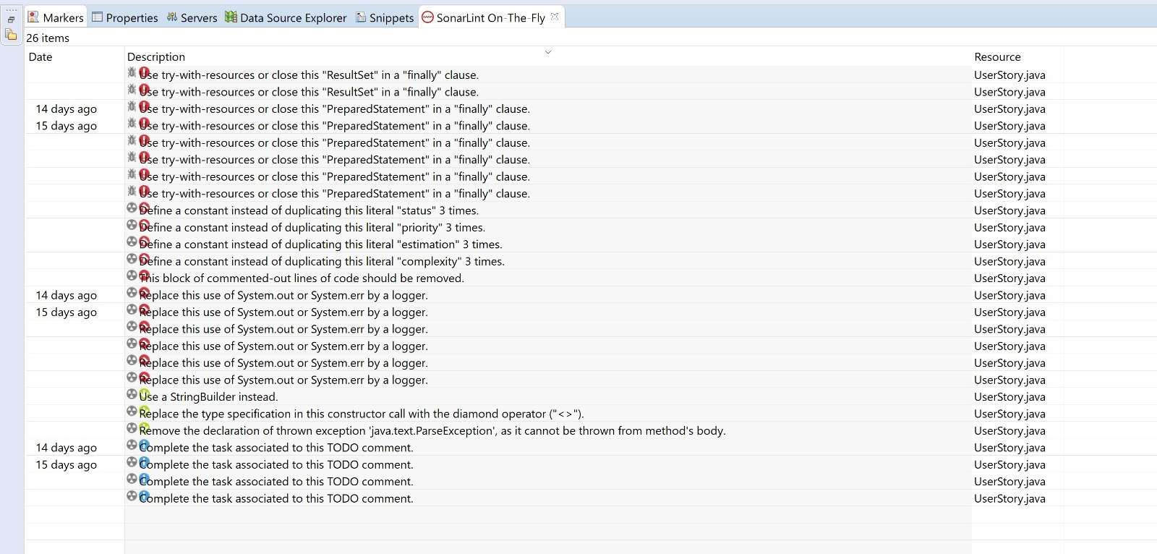

**JSP Files :**

* + - * 1. Registration.jsp

Developed by Chirag

Inspected by Harsh 2nd Oct

* + - * 1. Login.jsp

Developed by Chirag

Inspected by Srinath on 3rd Oct

* + - * 1. CreateFeatures.jsp

Developed by Deepika

Inspected by Harsh on 5th Oct

* + - * 1. CreateProject.jsp

Developed by Chirag

Inspected by Deepika on 3rd Oct

* + - * 1. CreateRelease.jsp

Developed by Srinath

Inspected by Harsh on 5th Oct

* + - * 1. CreateSprint.jsp

Developed by Deepika

Inspected by Harsh on 8th Oct

* + - * 1. CreateStory.jsp

Developed by Deepika

Inspected by Harsh on 12th Oct

* + - * 1. CreateTask.jsp

Developed by Chirag

Inspected by Srinath on 8th Oct

* + - * 1. Dashboard.jsp

Developed by Srinath

Inspected by Harsh on 3rd Oct

* + - * 1. ProductBacklog.jsp

Developed by Deepika

Inspected by Harsh on 14th Nov

* + - * 1. Sandbox.jsp

Developed by Harsh

Inspected by Chirag on 12th Nov

* + - * 1. Timeline.jsp

Developed by Chirag

Inspected by Srinath on 12th Nov

* + - * 1. ViewEditFeature.jsp

Developed by Deepika

Inspected by Harsh on 1st Nov

* + - * 1. ViewEditRelease.jsp

Developed by Deepika

Inspected by Harsh on 1st Nov

* + - * 1. ViewEditSprint.jsp

Developed by Deepika

Inspected by Harsh on 25th Oct

* + - * 1. ViewEditStory.jsp

Developed by Harsh

Inspected by Deepika on 5th Oct

* + - * 1. ViewEditTask.jsp

Developed by Chirag

Inspected by Srinath on 5Th Oct

* + - * 1. ViewSprintPlan.jsp

Developed by Srinath

Inspected by Harsh on 1st Nov

* + - * 1. ViewStoryPlan.jsp

Developed by Harsh

Inspected by Deepika on 25th Nov

* + - * 1. ViewUpdateProject.jsp

Developed by Deepika

Inspected by Chirag on 25Th Nov

Unused tags, commented code and indentation issues are found in all files and have been since fixed.

# Recommendations and Conclusions

Further testing of all the linkages between different entities like user stories, tasks, projects and, sprints can be done. Initially, testing covered basic functionalities but later the inspection can be more rigorous specifically emphasizing on the connection and redirection from different JSP pages.

# Project Issues

## Waiting Room

The next release for the project can include the following enhancements:

1. Chatroom: A feature to embed a chatroom within the Nouveau scrum software in order to facilitate smooth communication between the scrum team members.
2. Compatibility with GIT: One more enhancement can be an API to integrate GIT with Nouveau Scrum.

## Project Retrospective

*Things that went well:*

1. Working in a team of 4 from beginning for both the projects helped in task management and team player skills.
2. Development Project helped in understanding the implementation and usage of a UML diagrams.
3. Practicing Agile methodology for the project helped in understanding the scrum concepts thoroughly.
4. The descriptions provided in the sample report were very descriptive and self-explanatory.
5. Scores were evenly distributed with ample opportunities for improvement.

*Things that could be improved:*

1. Context switching between development and coding project was difficult and confusing. So, if we had first half of the course focused on coding and second half focused on development, it could have helped us focus in a better way.

# Glossary

* Agile:Agile software development is a group of software development methods in which requirements and solutions evolve through collaboration between self-organizing, cross-functional teams.
* Project Management tool:
* Sandbox: Initial stage where any person related or not related to the project can provide ideas. User stories are created here.
* Features: Functional Requirements are categorized into features.
* Project: A project is a collection of stories and sprints. The system allows multiple people to join a project and create/view stories and sprints within a project.
* Timeline: Timeline will contain all release and sprint level info along with the user stories and schedule of the project.
* Task: A specific task that needs to implement a feature described by a story.
* Sprint: A time period that has a start date and an end date. The system allows users to assign stories to a sprint. The goal is to create a deadline for stories to be implemented.
* Story: An explanation of a feature that needs to be implemented. The system allows developers to create stories and places them in the project Sandbox. A manager can accept to story, moving it to the Product Backlog, or reject the story, removing it from the Sandbox.
* Product Backlog: All User stories accepted by the project manager are stored in product backlog.

# References / Bibliography

|  |  |  |  |  |  |  |  |
| --- | --- | --- | --- | --- | --- | --- | --- |
| [1] | Software Engineering Project Report: "Nouveau Scrum" by Patrick Tam, Louis Ludkowski, Emanuil Dobrev, Vismaya Panchasheelan, March 2016.   |  |  | | --- | --- | |  |  | |  |  | | [2] | M. Fowler, UML Distilled, Third Edition, Boston: Pearson Education, 2004. | |

# Index

**No index entries found.**